Java JDBC Tutorial->

*Java JDBC is a java API to connect and execute query with the database.

*JDBC API uses jdbc drivers to connect with the database.

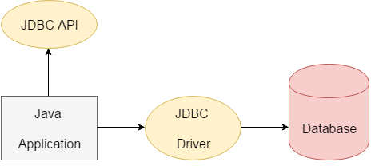

### **Why use JDBC->**

*Before JDBC, ODBC API was the database API to connect and execute query with the database.

* But, ODBC API uses ODBC driver which is written in C language (i.e. platform dependent and unsecured).

* That is why Java has defined its own API (JDBC API) that uses JDBC drivers (written in Java language).

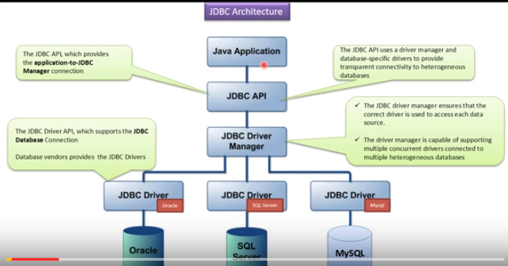

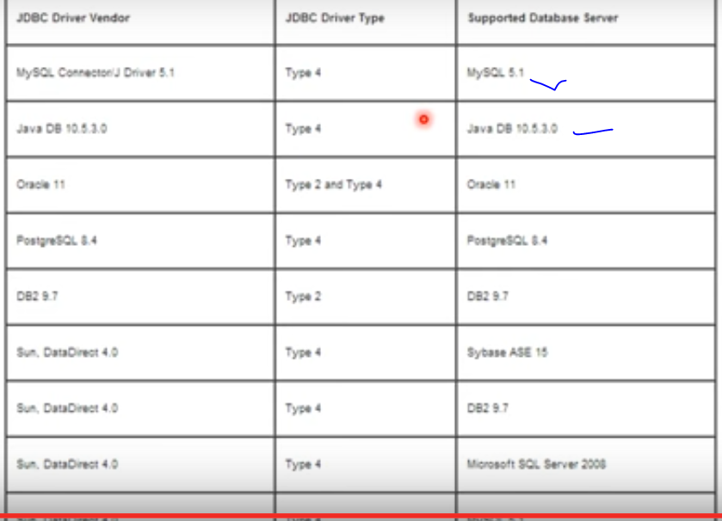

## **What is API->**

**\*API (Application programming interface) is a document that contains description of all the features of a product or software.**

**\*It represents classes and interfaces that software programs can follow to communicate with each other. An API can be created for applications, libraries, operating systems, etc**

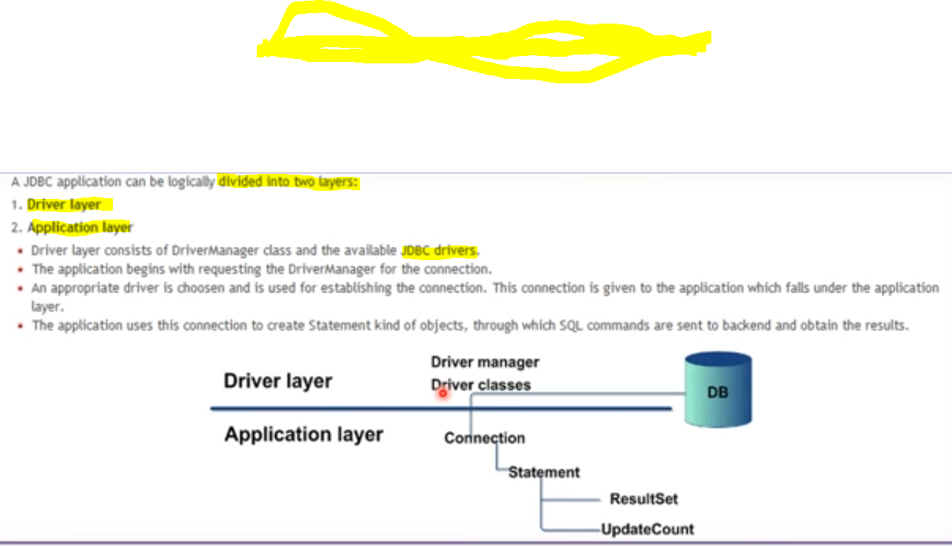

**Steps to connect DATABASE->**

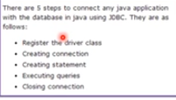

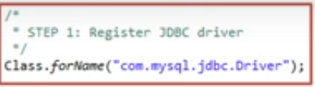

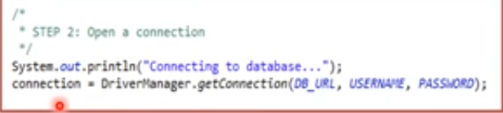

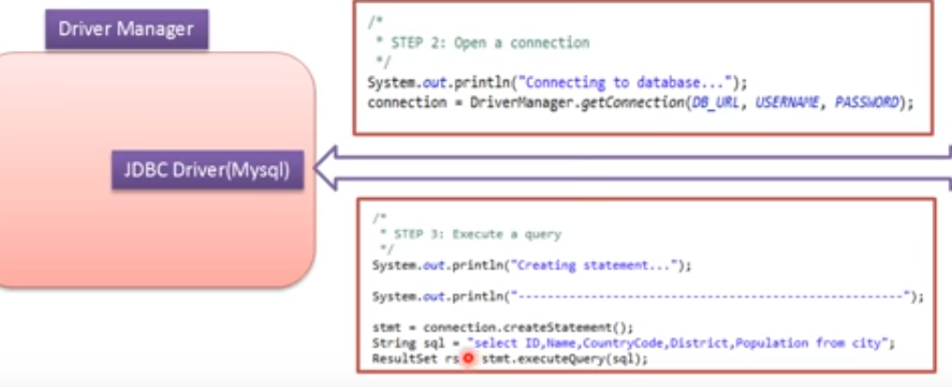

**We will get result at result set from sql;**

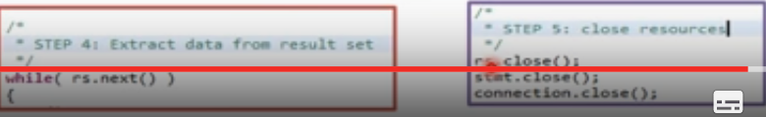

**4.th read data from while loop;**

**And 5th close all connection**

**Then making an statement->**

**Statement interface** provides methods to execute queries with the database. The statement interface is a factory of ResultSet i.e. it provides factory method to get the object of ResultSet.

### **Commonly used methods of Statement interface:**

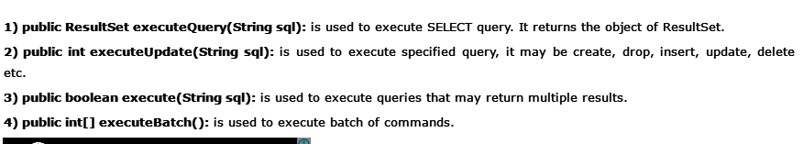

# ResultSet interface->

# The object of ResultSet maintains a cursor pointing to a row of a table. Initially, cursor points to before the first row.

# 